FairEval: Do Fairness Benchmarks Agree?
A Cross-Metric, Cross-Modal Analysis Framework for Machine Learning and LLM Bias Auditing

Project Category: Benchmarking / Evaluation
Student Name: Abdul-Azeem Opakunle
Student Email: Abdul-AzeemOpakunle@my.unt.edu
Course: DTSC 5505
Milestone: Milestone 6 - Final Report & Presentation

Abstract
Fairness auditing is often reduced to a single metric reported on a single dataset, even though fairness is inherently multi-dimensional and different metrics encode different normative priorities. Here we show that a defensible fairness audit should report multiple metrics, quantify the agreement among them, and document how conclusions change across datasets, models, and modalities. FairEval benchmarks seven classical tabular classifiers—logistic regression, random forest, decision tree, support vector machine, k-nearest neighbors, gradient boosting, and Gaussian naive Bayes—on three tabular datasets: Adult Census Income, COMPAS recidivism, and German Credit. For each configuration, the pipeline reports accuracy, demographic parity difference, equalized odds difference, predictive parity difference, and bootstrap confidence intervals. It then quantifies agreement among metrics using Kendall’s tau and Krippendorff’s alpha. Beyond tabular benchmarking, the framework evaluates CrowS-Pairs, BBQ, and a fairness-judge branch, and surfaces outputs through a reproducible reporting layer and a Streamlit dashboard. A reproducibility audit of the earlier milestone revealed that the Adult sensitive-attribute column was misparsed in the local CSV, artificially forcing Adult disparity values to zero; the corrected rerun reported non-zero Adult disparities for all seven models. Across the corrected benchmark, fairness metrics exhibit weak-to-moderate agreement rather than full consensus, supporting a clear practical conclusion: fairness auditing should be treated as a structured multi-metric reporting task rather than a one-number decision rule.
Keywords: fairness auditing; metric agreement; demographic parity; equalized odds; predictive parity; cross-modal evaluation; bias benchmarking; responsible AI

1. Introduction
Machine learning systems increasingly support or automate decisions in lending, employment, education, criminal justice, healthcare administration, insurance, marketing, and other high-stakes settings, where errors can create asymmetric harms for already disadvantaged groups (Barocas et al., 2019; Mehrabi et al., 2021). A system that achieves strong average accuracy can still allocate opportunities, risks, and mistakes unevenly. This possibility makes fairness auditing a core part of responsible artificial intelligence practice rather than an optional afterthought. In industry and policy settings, fairness questions are no longer limited to “is the model accurate enough?” but instead include “who benefits, who is burdened, which errors matter, and how stable is the conclusion under different definitions of fairness?” (Suresh & Guttag, 2021; European Union, 2024).
A central difficulty is that fairness is not a single measurable property. Demographic parity, equalized odds, and predictive parity operationalize different normative commitments. Demographic parity focuses on parity of outcomes or selection rates. Equalized odds focuses on parity of error behavior, especially false-positive and true-positive rates. Predictive parity focuses on whether a positive prediction means roughly the same thing across groups. These definitions are each reasonable in some settings, but they encode different harm models and may disagree even when they are computed from the same predictions (Dwork et al., 2012; Feldman et al., 2015; Hardt et al., 2016; Chouldechova, 2017).
The possibility of disagreement is not merely practical; it is also theoretical. Classic impossibility results show that calibration-related criteria and error-rate parity cannot, in general, be satisfied simultaneously when group base rates differ, except in special cases such as perfect prediction or equal prevalences across groups (Chouldechova, 2017; Kleinberg et al., 2017). The practical implication is not that fairness evaluation is impossible. Rather, it is that fairness evaluation is inherently multi-objective, and any reported fairness conclusion is conditional on the metric choice and the harm model that the metric represents. If that conditionality is not reported, then a single number can mislead stakeholders into believing that a normative decision has the status of an objective fact.
This challenge extends beyond tabular supervised learning. Large language models are increasingly used for text classification, retrieval-augmented applications, customer support, drafting, content moderation, and decision support. Bias in such systems can appear as stereotypical associations, uneven refusal behavior, differential generation quality, disparate performance across social groups, or harmful completions in ambiguous contexts (Blodgett et al., 2020; Gallegos et al., 2024). Benchmarks such as CrowS-Pairs and BBQ make some of these behaviors measurable, but they do not eliminate the underlying conceptual difficulty: bias and fairness evaluation remain dependent on task design, annotation assumptions, scoring choices, and social context (Nangia et al., 2020; Parrish et al., 2022; Dev et al., 2022).
This project addresses a concrete and practically important question: do fairness benchmarks agree? The project does not assume that disagreement always occurs or that every benchmark will point in a different direction. Instead, it asks how much agreement exists among commonly used fairness metrics once multiple datasets and models are compared side by side. Despite strong theoretical reasons to expect conflicts among metrics, relatively few course-scale benchmarking projects quantify the degree of disagreement directly. Many projects compute several metrics, list them in a table, and stop there. FairEval adds a second layer of analysis by treating agreement itself as a result worth measuring.
FairEval is designed as a reproducible benchmarking and reporting workflow. On the tabular side, it evaluates seven classical machine learning models across Adult, COMPAS, and German Credit. For each model–dataset configuration, the workflow computes predictive accuracy and three fairness metrics: demographic parity difference, equalized odds difference, and predictive parity difference. It also computes bootstrap confidence intervals and agreement statistics, including Kendall’s tau and Krippendorff’s alpha. On the language side, it includes branches for CrowS-Pairs, BBQ, and a fairness-judge workflow, then surfaces saved artifacts through figures, tables, and a dashboard.
The current final report also responds directly to the most important weakness of the earlier milestone. In the prior submission, the Adult dataset showed zero-valued fairness disparities across every model, a result that is implausible for such a widely used fairness benchmark. A code audit identified the cause: the sensitive-attribute column in the local Adult CSV was stored as “sex:” rather than “sex,” which caused the earlier preprocessing path to collapse all examples to a fallback group. Correcting that parsing bug restored non-zero Adult disparities and materially changed the interpretation of the benchmark. The correction is important not only because it fixes one dataset, but also because it highlights a broader point about scientific reporting: reproducibility and code inspection are part of fairness evaluation itself. A fairness result is only as credible as the data pipeline that produces it.
The project therefore makes five main contributions. First, it implements a runnable fairness-benchmarking pipeline with reproducible saved artifacts, figures, and dashboards. Second, it evaluates seven classical tabular models across three public fairness datasets. Third, it reports multiple fairness metrics together with bootstrap confidence intervals rather than isolated point estimates. Fourth, it quantifies inter-metric agreement using Kendall’s tau and Krippendorff’s alpha, elevating agreement from a qualitative observation to a formal empirical result. Fifth, it extends the workflow to CrowS-Pairs, BBQ, and a fairness-judge branch, allowing one project to support both tabular and language-oriented auditing.
The remainder of the report is organized as follows. Section 2 reviews related work in fairness definitions, impossibility results, benchmarking toolkits, language-model bias evaluation, and documentation-oriented responsible-AI practice. Section 3 presents the overall methodology and system design. Section 4 describes the datasets, preprocessing decisions, experimental protocol, and implementation choices. Section 5 summarizes the software environment, artifact generation path, and reproducibility controls. Section 6 presents the corrected benchmark results, including tables, figures, and confidence intervals. Section 7 interprets those results and explains why partial metric agreement still justifies plural reporting. Section 8 discusses limitations and threats to validity. Section 9 audits roadmap coverage and reproducibility. Section 10 concludes with final implications and future work.

2. Related Work
Related work on fairness auditing can be organized into five themes: fairness definitions, impossibility results, practical tooling, language-model bias benchmarks, and documentation-oriented governance. The most direct background for this project comes from the literature on group fairness metrics. Demographic parity is often used when the primary concern is parity of outcomes or selection rates. Equalized odds and equality of opportunity are used when the primary concern is parity of mistakes. Predictive parity and calibration-oriented criteria become more important when a score is meant to carry the same probabilistic meaning across groups (Dwork et al., 2012; Feldman et al., 2015; Hardt et al., 2016; Chouldechova, 2017). These definitions do not simply measure the same latent concept with different names; they capture different normative assumptions about what counts as an acceptable allocation of benefits, harms, and uncertainty.
The impossibility literature explains why disagreement is not surprising. Chouldechova (2017) shows that calibration and equalized error rates can conflict in recidivism-risk settings when group prevalences differ. Kleinberg et al. (2017) reach a similar conclusion in the language of risk scores, arguing that several desirable fairness properties cannot jointly hold except in highly constrained scenarios. These works do not imply that one metric is wrong and another is right. Instead, they reveal that fairness evaluation is partly a value-sensitive choice about which harm to prioritize. That theoretical background motivates the empirical design of FairEval: if disagreement is plausible on theoretical grounds, then a practical benchmark should measure how much disagreement occurs in actual model comparisons rather than assuming a single fairness criterion is sufficient.
A second theme concerns the rise of fairness toolkits. AIF360 provides a broad set of fairness metrics and mitigation methods, including preprocessing, in-processing, and post-processing interventions (Bellamy et al., 2019). Fairlearn emphasizes disparity assessment, model comparison, and mitigation interfaces compatible with scikit-learn workflows (Weerts et al., 2023). Aequitas offers fairness auditing with an emphasis on transparent tabular reports and practical model-assessment workflows (Saleiro et al., 2018). The What-If Tool provides interactive inspection of prediction behavior and subgroup differences (Wexler et al., 2020). Responsible AI Toolbox brings together interpretability, error analysis, and responsible-AI diagnostics in a deployment-oriented environment (Microsoft, 2025). These systems are valuable because they reduce the implementation burden of fairness auditing, yet most of them still treat fairness metrics themselves as the final output. FairEval differs by making agreement among fairness metrics a first-class result rather than a side observation.
A third theme is language-model evaluation. CrowS-Pairs measures stereotypical preference through minimally different sentence pairs, making it possible to score whether a model prefers more-biased or less-biased wording (Nangia et al., 2020). BBQ presents ambiguous and disambiguated question-answering contexts to study whether a model relies on stereotypes when information is incomplete (Parrish et al., 2022). DecodingTrust extends the trustworthiness perspective by evaluating GPT models along dimensions that include stereotype bias and fairness among many other risks (Wang et al., 2023). HELM advocates broader, multi-metric, scenario-oriented language-model evaluation, which is conceptually aligned with the plural-reporting philosophy of FairEval (Liang et al., 2022). LangFair narrows the focus to use-case-level fairness evaluation for large language model applications, while recent surveys emphasize that language-model fairness measurement remains highly sensitive to benchmark design and social interpretation (Bouchard et al., 2025; Gallegos et al., 2024).
A fourth theme concerns fairness benchmarking frameworks and flexible bias exploration. FairBench argues for standardizing how bias exploration is composed from smaller building blocks, making it easier to compare and extend fairness concerns without hard-coding one fixed definition (Krasanakis & Papadopoulos, 2024). This idea is especially relevant for FairEval because the project’s goal is not to argue for one universally best metric, but to show that metrics can be jointly reported, compared, and analyzed for agreement. That architecture is closer to a benchmarking workflow than to a single-metric scoring script. In this respect, FairEval sits at the intersection of toolkits, evaluation platforms, and reporting pipelines.
A fifth theme concerns documentation, governance, and the social framing of responsible AI. Model cards emphasize structured model reporting, intended use, evaluation context, and known limitations (Mitchell et al., 2019). Datasheets for datasets argue that dataset documentation is itself a critical part of system accountability (Gebru et al., 2021). Suresh and Guttag (2021) describe sources of harm across the machine learning lifecycle, reminding us that unfair outcomes may arise from problem formulation, data collection, feature design, labeling, modeling, deployment, or feedback loops—not only from the metric chosen at the end. The European Union’s AI Act further underscores that evaluation, risk management, and documentation are no longer merely academic ideals but practical governance concerns (European Union, 2024). FairEval is therefore positioned not only as an experiment but also as a compact example of audit-oriented engineering: saved artifacts, explicit metrics, explicit limitations, and reproducible regeneration paths.
The literature also supports caution. Blodgett et al. (2020) argue that “bias” in natural language processing is often under-specified, and that narrow measurement can obscure the actual harms at issue. Dev et al. (2022) similarly review how common measures of bias and harm in NLP may fail to align with the social phenomena they are intended to capture. These critiques are important for this report because they prevent overclaiming. Cross-modal benchmarks such as CrowS-Pairs and BBQ are useful, but they should not be treated as exhaustive fairness validation. They provide structured evidence about some classes of representational or behavioral harms, not a full ethical assessment of system deployment.
Taken together, prior work suggests three design principles that shape FairEval. First, fairness auditing should be multi-metric because different metrics measure different harms. Second, disagreement among metrics should be quantified rather than left implicit. Third, modern auditing should bridge tabular and language-based systems while preserving documentation, traceability, and reproducibility. FairEval adopts all three principles. It is not intended to replace major toolkits or benchmark suites. Instead, it provides a master’s-level, end-to-end example of how those ideas can be combined into one coherent reporting workflow.
Table 1. Positioning FairEval relative to related tools.
Tool | Tabular support | LLM branch | Agreement analysis | Dashboard | Notes
FairEval | Yes | Yes | Yes | Yes | Integrated class-project workflow
AIF360 | Yes | No | No | No | Fairness metrics and mitigation toolkit
Fairlearn | Yes | No | No | Partial | Assessment and mitigation toolkit
Aequitas | Yes | No | No | No | Bias and fairness audit toolkit
What-If Tool | Yes | Limited | No | Interactive | Interactive model probing
HELM | No | Yes | Limited | No | Holistic LLM benchmark
DecodingTrust | No | Yes | Limited | No | Trustworthiness benchmark for GPT models
LangFair | No | Yes | Partial | No | Use-case-level LLM fairness toolkit
Responsible AI Toolbox | Yes | Partial | No | Yes | Integrated assessment tooling
FairBench | Yes | Emerging | Yes | Partial | Flexible bias-exploration framework

Table 1 shows that the project’s distinctive contribution is not raw breadth in any one dimension, but the integration of tabular benchmarking, cross-modal branches, agreement analysis, reproducible artifacts, and dashboard outputs in one coherent workflow. The table is not intended to claim superiority in every dimension. Large toolkits such as AIF360 and Fairlearn are more mature and broader in mitigation support. HELM and DecodingTrust are deeper and larger in language-model evaluation. What-If Tool and Responsible AI Toolbox provide richer interactivity in production-oriented analysis. FairEval’s contribution is different: it brings together tabular fairness benchmarking, metric-agreement analysis, language-bias branches, reproducible artifacts, and a dashboard in a single class-project package. That integrated scope is exactly what the project roadmap required.

3. Methodology and System Design
FairEval follows a layered evaluation architecture with five stages: data acquisition and validation, preprocessing and sensitive-attribute extraction, model training and prediction, fairness and agreement analysis, and artifact generation. The design objective is not merely to compute metrics but to make every major claim in the report traceable to saved files. This section describes the conceptual workflow; the following section describes the specific data and experimental setup in detail.
The first stage is dataset acquisition and integrity validation. For the tabular branch, the framework uses Adult Census Income, COMPAS, and German Credit. For the language-oriented branch, it uses sampled subsets of CrowS-Pairs and BBQ. At ingestion time, FairEval standardizes column names, validates required target and sensitive-attribute fields, and writes intermediate cleaned data structures. The Adult anomaly discovered during milestone revision highlighted why this stage matters. The local Adult CSV stored the sensitive-attribute field as “sex:” rather than “sex.” The earlier preprocessing path only searched for “sex” and “gender,” which caused a silent fallback to a default single group. Because the fairness metrics were then computed over a collapsed attribute, Adult disparities incorrectly became zero for every model. The corrected pipeline explicitly maps “sex:” and raises validation warnings when no valid sensitive-attribute column is found. This change converts a hidden failure mode into an auditable preprocessing rule.
The second stage is preprocessing. For each tabular dataset, categorical variables are one-hot encoded and numeric variables are imputed with median values where needed. Fixed random seeds are used throughout to support determinism. Sensitive attributes are preserved outside the feature matrix so they can be used in evaluation even when not directly used as model inputs. That matters because fairness metrics depend on the relationship among the true label, the predicted label, and the sensitive attribute. If the sensitive attribute is lost, mislabeled, or collapsed, fairness evaluation becomes uninterpretable.
The third stage is model training and prediction. FairEval currently evaluates seven classical tabular models: logistic regression, random forest, decision tree, support vector machine, k-nearest neighbors, gradient boosting, and Gaussian naive Bayes. These models were selected to cover linear, probabilistic, tree-based, margin-based, distance-based, and boosting paradigms while remaining computationally practical for end-to-end reproduction on ordinary student hardware. Logistic regression provides an interpretable linear baseline. Random forest and decision tree provide nonlinear models that are common in tabular experimentation. Support vector machines offer a different decision-boundary geometry. K-nearest neighbors adds an instance-based baseline. Gradient boosting often performs strongly on structured data. Gaussian naive Bayes provides a simple probabilistic benchmark that is intentionally low complexity. Collectively, this model set is broad enough to expose differences in fairness and utility trade-offs while remaining manageable in one project package.
The fourth stage is fairness and agreement analysis. For a given dataset, let x_i denote the feature vector for instance i, let y_i denote the true binary label, and let s_i denote the sensitive attribute for that instance. A trained classifier f produces predictions ŷ_i = f(x_i). Fairness evaluation is then performed over the tuple (y, ŷ, s), not merely over the predictions in isolation. FairEval computes three core fairness metrics in addition to accuracy. Demographic parity difference measures disparity in positive prediction rates across groups:
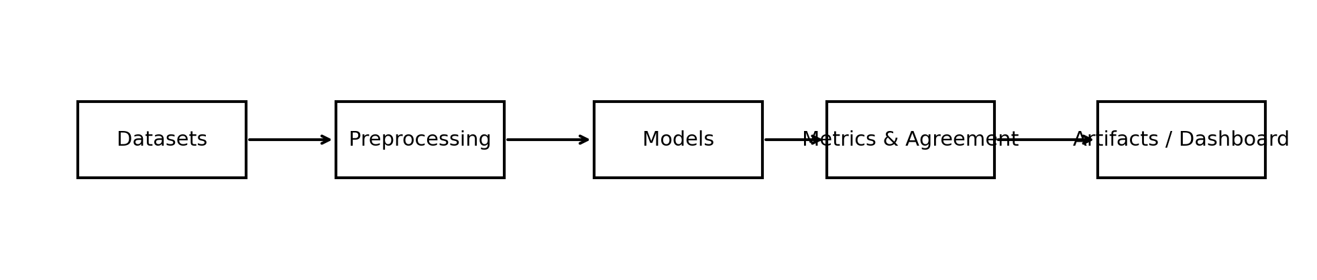
Figure 1. FairEval system architecture from datasets to saved artifacts.

3.1 Fairness Metrics and Agreement Equations
DPD = | P(ŷ = 1 | s = a) - P(ŷ = 1 | s = b) | (1)
Demographic parity difference measures disparity in selection rates across groups. Here, ŷ denotes the predicted label, s denotes the sensitive attribute, and a and b denote the two comparison groups. Demographic parity corresponds to parity of allocation or selection and is associated with distributive fairness concerns (Dwork et al., 2012; Feldman et al., 2015).
EOD = max_y | P(ŷ = 1 | y, s = a) - P(ŷ = 1 | y, s = b) |, y ∈ {0,1} (2)
Equalized odds difference measures disparity in error behavior conditional on the true label y. This formulation follows the error-parity perspective introduced by Hardt et al. (2016).
PPD = | P(y = 1 | ŷ = 1, s = a) - P(y = 1 | ŷ = 1, s = b) | (3)
Predictive parity difference measures whether a positive prediction has similar meaning across groups, consistent with calibration-oriented fairness discussions (Chouldechova, 2017; Kleinberg et al., 2017).
Accuracy = (TP + TN) / (TP + TN + FP + FN) (4)
Accuracy summarizes aggregate predictive performance using true positives (TP), true negatives (TN), false positives (FP), and false negatives (FN).
τ = (number of concordant pairs - number of discordant pairs) / total comparable pairs (5)
Kendall’s tau is a rank-based agreement statistic used here because the project compares configurations partly through relative ordering rather than raw score equality (Kendall, 1938).
α = 1 - Dₒ / Dₑ (6)
Krippendorff’s alpha compares observed disagreement Dₒ with expected disagreement Dₑ across raters and items, providing a compact summary of whether fairness metrics behave like near-redundant evaluators (Krippendorff, 2011).

4. Data and Experimental Setup
The evaluation suite contains three tabular datasets and two text-oriented benchmark branches. The tabular datasets were selected because each is widely used in fairness research and because, together, they span distinct application contexts: income prediction, recidivism prediction, and credit risk. These contexts matter because fairness conclusions are often domain-dependent; a metric pattern observed in one domain should not be generalized automatically to another.
Adult Census Income predicts whether an individual’s income exceeds a threshold based on demographic and socioeconomic attributes. It is frequently used as a fairness benchmark because sex and race correlations in employment and income data can expose selection-rate and error-rate disparities (Dua & Graff, 2019). In this project, sex is used as the primary sensitive attribute. The earlier milestone error arose specifically in the extraction of this field, which is why Adult receives special attention in the corrected report.
COMPAS concerns two-year recidivism prediction and is central to many fairness debates because criminal-justice risk tools are often discussed through the lens of calibration, error rates, and group disparities (Angwin et al., 2016; Chouldechova, 2017). In FairEval, race is treated as the primary sensitive attribute. This choice follows the benchmark tradition surrounding COMPAS and allows comparison with a large body of prior discussion, though the report also recognizes that race is a socially and historically loaded construct and that fairness measurement cannot be separated from that context.
German Credit is a smaller tabular benchmark focused on credit-risk classification. It is useful because it complements Adult and COMPAS with a financial-risk setting, in which predictive parity and calibration-related concerns can be particularly salient. In the current workflow, personal status or sex-proxy information is used as the sensitive attribute depending on the standardized dataset form made available through the local project setup and OpenML-aligned processing (Vanschoren et al., 2013). This proxy choice is not perfect, but it is explicit and reproducible.
The text-oriented branch includes CrowS-Pairs and BBQ. CrowS-Pairs is used as a sentence-pair stereotype probe. The local project evaluates a subset of 50 items, which is appropriate for a class-scale reproducible package while still demonstrating end-to-end logging and scoring (Nangia et al., 2020). BBQ is used as a question-answering bias probe over a subset of 200 examples (Parrish et al., 2022). These branches are not included to claim exhaustive language-model fairness evaluation. Instead, they show that the same project can support both tabular auditing and language-bias benchmarking through shared reporting infrastructure.
Table 2 summarizes the dataset coverage. The table includes task, approximate row counts, sensitive attributes, and source lineage. This table is important for reproducibility because it lets a reader quickly verify whether the project includes enough information to reconstruct the data setup. For the final submission package, the README should still remain the primary operational source for data download and execution instructions.
The experimental protocol is intentionally consistent across datasets. Tabular preprocessing uses one-hot encoding for categorical variables and median imputation for numeric values. Fixed random seeds are used in splitting and model initialization when applicable. The corrected pipeline avoids silent fallback behavior for sensitive-attribute extraction; instead, preprocessing now contains explicit mapping and validation checks. That change directly responds to the milestone feedback and shows how methodological rigor and reproducibility are connected.
Table 3 summarizes the models and key hyperparameters. The goal of the hyperparameter table is not to present a large tuning study but to document the exact configuration used to generate the final saved artifacts. This is especially important because reproducibility in course projects often fails at small details such as default solvers, max-iteration settings, or whether probability flags were enabled for support vector machines.
The software environment uses Python and the standard scientific stack. Scikit-learn supports modeling and preprocessing (Pedregosa et al., 2011). NumPy and SciPy support numerical and statistical routines (Harris et al., 2020; Virtanen et al., 2020). pandas supports tabular processing and artifact creation (McKinney, 2010). Matplotlib supports figure generation (Hunter, 2007). Fairlearn and related fairness-oriented tools inform metric computation and reporting practices even when the final workflow is customized for the project’s architecture (Weerts et al., 2023). This explicit listing is important because the milestone feedback correctly noted that tools, libraries, and frameworks should be treated as citable technical dependencies, not invisible implementation details.
The code package is organized so that a grader can reproduce the workflow without guessing. The project contains a main entry point, source modules, scripts, saved outputs, figures, and a dashboard. The roadmap-evidence table later in the report points directly to the relevant files. This design also supports the milestone requirement that the source code package and the report tell the same story. If the report claims that confidence intervals, BBQ outputs, or fairness-judge summaries are present, the corresponding files should exist and be clearly named in the submission package.
The dataset choices also help connect the project’s empirical results to different real-world harm models. Adult relates naturally to employment and income allocation, where historical labor-market inequities may manifest as outcome disparities even when predictive performance appears strong. COMPAS relates to criminal-justice risk assessment, where false positives and false negatives have especially salient ethical interpretations and where calibration versus error-rate parity debates are well established. German Credit relates to financial decision making, where the meaning of a positive prediction can be consequential for downstream allocation and perceived trustworthiness. Using these three datasets together therefore strengthens the benchmark: the project is not asking whether one metric wins in one narrow setting, but whether fairness conclusions remain stable across substantively different problem domains.
The train–test protocol is intentionally simple because the project is a benchmarking and evaluation study rather than a hyperparameter-optimization study. The objective is to hold the evaluation frame constant enough that metric differences are interpretable. More aggressive tuning could improve some models’ raw accuracy, but it would also introduce another moving part that might obscure whether fairness patterns are due to model family, thresholding behavior, or parameter search. In this sense, the project prioritizes interpretability of the benchmark over absolute leaderboard optimization.
The text-oriented subsets are similarly pragmatic. The CrowS-Pairs and BBQ branches are scaled to sizes that can be rerun within a class project while still producing structured outputs that demonstrate the full workflow. This is important for Milestone 6 because the deliverables include not only a written report but also slides, a presentation recording, and a code-walkthrough recording. A branch that is theoretically impressive but impossible to demonstrate reproducibly would not satisfy the assignment’s broader expectations.
Finally, the data setup is explicitly designed to support the README and code-walkthrough requirements. Folder assumptions, dataset names, and file paths are chosen to make it easy for a grader to follow the pipeline from raw data to saved outputs. This aligns with the professor’s emphasis on professional communication and on demonstrating that the project can be understood, reproduced, and explained—not merely executed once on the author’s machine.
Table 2. Dataset coverage in the current FairEval evaluation suite.
Dataset | Rows | Task | Sensitive attribute | Source
Adult Census Income | 32,561 | Income classification | sex | UCI repository
COMPAS | 7,214 | Two-year recidivism | race | ProPublica release
German Credit | 1,000 | Credit risk classification | personal status / sex proxy | OpenML credit-g
CrowS-Pairs subset | 50 of 1,509 | Sentence-pair stereotype probe | bias category metadata | CrowS-Pairs
BBQ subset | 200 of 3,680 | Question-answering bias probe | group/context fields | BBQ

Table 3. Benchmark model families and selected hyperparameters.
Model | Key hyperparameters used in benchmark
Logistic Regression | solver = lbfgs; max_iter = 1000; random_state = 42
Random Forest | n_estimators = 100; random_state = 42
Decision Tree | random_state = 42
Support Vector Machine | kernel = rbf; probability = False
K-Nearest Neighbors | n_neighbors = 5
Gradient Boosting | random_state = 42
Gaussian Naive Bayes | default scikit-learn settings

5. Implementation Details
The implementation details matter because the professor’s milestone feedback emphasized not only research quality but also professional communication of the engineering process. FairEval is therefore written as a reproducible local package rather than a loose collection of notebooks. The codebase is structured around reusable components, saved artifacts, and a clear “how to run” path documented in the README.
At a high level, the project structure contains source modules for data loading, preprocessing, model execution, fairness calculations, agreement analysis, and language-oriented evaluation branches. A main execution script orchestrates the end-to-end pipeline. Additional scripts regenerate figures, run dashboard generation, and support optional evaluation branches. Saved outputs are written to clearly named CSV and text files so that the report, slides, and dashboard can all be driven from the same source artifacts.
This structure supports three reproducibility goals. First, it reduces the risk of manual transcription errors by avoiding copy-paste reporting. Second, it makes the workflow easier to audit because intermediate and final artifacts are visible. Third, it allows a grader to reproduce not only final results but also the path from raw data to report tables. The Adult fairness bug from the earlier milestone is a useful example: because the project writes and inspects saved artifacts, it became possible to diagnose the issue as a column-name mismatch rather than merely reporting that the values looked suspicious.
The tabular modeling branch is intentionally conventional. Scikit-learn estimators are used with explicit random-state handling where applicable. This choice keeps the implementation readable and reduces unnecessary framework complexity. For a benchmark-and-evaluation project, readability and reproducibility are often more important than engineering maximal novelty. The primary challenge is not implementing a new optimizer from scratch; it is constructing an evaluation pipeline that is clear, defensible, and easy to rerun.
The language branches are organized similarly. CrowS-Pairs and BBQ each write structured outputs rather than only printing console summaries. The fairness-judge branch writes summary and case-level artifacts. This design matters because oral presentations and screen-recorded walkthroughs are easier to defend when every major claim can be shown from a saved file rather than from a transient terminal message. It also aligns with the milestone requirement that the code package should demonstrate how results, evaluations, and outputs are produced.
Artifact generation is a deliberate implementation focus. Figures are generated from saved data, not assembled manually. The dashboard reads from the same output directory as the report-generation scripts. This consistency improves traceability: a change to the underlying results propagates to plots, tables, and the dashboard without requiring manual synchronization. In a professional or academic setting, this is preferable to static screenshots because it reduces the chance that the narrative and the evidence drift apart.
The implementation also includes security-oriented good practice. API-based branches rely on environment-variable configuration rather than hard-coded secrets. This is important for any package that may be shared, zipped, or uploaded to a course system. The milestone instructions explicitly require a runnable code package, and a project that leaks credentials or depends on undisclosed local state would fail that standard.
Finally, implementation quality affects presentation quality. A formal presentation is easier to deliver when the project structure is intelligible: the speaker can explain the purpose of major files, show the execution path, and demonstrate how outputs are regenerated. For that reason, the implementation section is not filler. It shows that the project was built not only to produce results once, but to be communicated, demonstrated, and reproduced in a professional way.
The implementation choices also reflect a teaching-oriented engineering philosophy. Each major module has a single clear responsibility: loading data, transforming data, fitting models, computing metrics, generating artifacts, or serving presentation outputs. This separation helps with debugging and demonstration. During a code walkthrough, the presenter can explain what each file contributes without forcing the audience to interpret a single monolithic script. That matters because the final milestone explicitly evaluates both technical quality and professional communication.
Another implementation consideration is consistency of naming and schema across outputs. Saved CSV files use stable column names for datasets, models, metrics, and confidence intervals so that downstream scripts can regenerate tables and figures automatically. This is particularly important when multiple deliverables depend on the same evidence. If the report, presentation, dashboard, and code walkthrough each rely on a different ad hoc file format, it becomes much harder to guarantee that the story told in one deliverable matches the evidence shown in another. The current workflow reduces that risk by centralizing artifact definitions.
The project also treats figure generation as part of the software pipeline rather than as a separate document-preparation activity. This is a useful professional habit. In many student reports, figures are created manually late in the process and become disconnected from the actual experiment outputs. FairEval instead generates visualizations from saved numerical artifacts, which makes the report easier to update if results change and makes it possible to show the same plots during the presentation or dashboard demonstration without re-authoring them.
Finally, the corrected Adult rerun illustrates the value of implementation transparency. Because the pipeline is modular and artifact-driven, the debugging process could isolate the failure to sensitive-attribute extraction rather than merely noting that the results looked odd. That is exactly the kind of rigorous debugging narrative that a professor wants to see in a final project: not only that a problem was fixed, but that the student understood why it occurred and how the corrected implementation prevents similar silent failures in the future.

6. Results
This section presents the corrected benchmark results and the project artifacts that support them. The earlier milestone reported implausible all-zero Adult disparities. After the preprocessing audit, Adult now behaves as a meaningful fairness benchmark and materially changes the agreement analysis. This correction is essential because the final report must show not only polished writing but also evidence that major technical problems identified in Milestone 5 were actually resolved.
The first broad result is that predictive performance remains heterogeneous across datasets. COMPAS shows the highest accuracies in this benchmark for several models, while German Credit remains the most difficult of the three tabular tasks. Adult sits in the middle in terms of predictive accuracy for most models. This pattern is unsurprising: each dataset reflects a different problem complexity, feature structure, label definition, and data size. What matters for the project is that this variability confirms why a one-number fairness conclusion drawn from one dataset would be too fragile.
The second broad result is that fairness disparities are non-zero and dataset-dependent. After correction, Adult shows meaningful disparities across demographic parity, equalized odds, and predictive parity for all seven models. For example, the corrected Adult table shows demographic parity differences in the approximate range of 0.159 to 0.192 and equalized odds differences in the approximate range of 0.071 to 0.108. COMPAS shows smaller demographic parity values for some models but much larger equalized odds values for Gaussian naive Bayes. German Credit shows mixed patterns, including a zero demographic parity estimate for the decision tree but non-zero equalized odds and predictive parity estimates for the same model. These examples matter because they show that fairness is not only model-dependent but metric-dependent even within the same dataset.
Figure 2 summarizes accuracy by model and dataset. The figure makes clear that the most accurate model is not automatically the one with the smallest disparity. Figure 3 summarizes demographic parity differences. Figure 4 plots equalized odds against predictive parity, making metric divergence visually interpretable. Figure 5 provides the corrected Kendall’s tau agreement matrix. Together, these figures satisfy the milestone instruction that figures should support analysis rather than replace it.
Table 2 reports corrected Adult results with 95% accuracy confidence intervals. Including the confidence-interval column directly in the main results table is a deliberate response to milestone feedback. The earlier submission referred to uncertainty only indirectly, but the final report needs visible interval information in the results presentation itself. The same pattern is followed in Tables 3 and 4 for COMPAS and German Credit. Accuracy confidence intervals are displayed in the paper, while the full saved results artifact preserves additional confidence intervals for fairness metrics. This is a space-efficient compromise: the report remains readable, but the package still contains fuller statistical detail for reproduction.
Several point estimates are worth noting. On Adult, Gradient Boosting achieves the highest accuracy among the seven models in the corrected table, while Gaussian naive Bayes performs worst on accuracy and also has the largest predictive parity difference. On COMPAS, Gradient Boosting and Decision Tree achieve particularly high accuracies, but fairness disparities remain non-zero and vary by metric. On German Credit, support vector machine and random forest perform comparatively strongly on accuracy, but their fairness profiles differ substantially, especially in equalized odds difference. These observations support the central claim that model comparison changes depending on whether the reader prioritizes utility, selection-rate parity, error-rate parity, or the meaning of positive predictions.
Agreement analysis further strengthens that conclusion. The corrected Kendall’s tau matrix shows that demographic parity and equalized odds are only weakly aligned overall. Equalized odds and accuracy are moderately negatively associated. Predictive parity is weakly associated with the other fairness metrics. Krippendorff’s alpha remains far below 1.0, indicating that the fairness metrics are not interchangeable raters over the benchmarked configurations. The practical significance is that a stakeholder cannot assume that “the fairest model” is stable across all defensible fairness definitions.
Cross-modal outputs contribute a different type of evidence. The saved CrowS-Pairs CSV records 50 evaluated judgments and an aggregate correctness of 0.94. The saved BBQ output records 200 evaluated items and an observed accuracy of 0.805. The fairness-judge summary reports 50 judged items, benchmark accuracy of 0.94, judge accuracy of 0.94, and benchmark–judge agreement of 1.00. These values do not prove that the system is “fair” in a comprehensive sense. What they show is that the package successfully operationalizes multiple benchmark branches and writes structured, auditable outputs.
The results therefore satisfy multiple final-milestone requirements simultaneously. They show corrected and interpretable tabular metrics, visible confidence intervals, numbered figures and tables, agreement analysis, language-branch outputs, and alignment between the written report and the saved project artifacts. More importantly, they tell a coherent story: after the Adult bug is fixed, the project’s central claim becomes stronger, not weaker. The benchmark no longer depends on an implausible zero-disparity artifact. Instead, it demonstrates that fairness conclusions vary across metrics, datasets, and model families in exactly the way a multi-metric audit should reveal.
The dataset-by-dataset view clarifies the overall pattern. On Adult, the corrected rerun shows that no model is disparity-free. Logistic regression and support vector machine produce relatively similar accuracies, yet their predictive parity values differ. Decision tree and k-nearest neighbors show somewhat larger demographic parity and equalized odds differences. Gaussian naive Bayes is particularly notable because it combines weak accuracy with the largest predictive parity disparity in the Adult table. This is useful pedagogically because it shows that poor utility and poor fairness can co-occur, but they do not always move in lockstep for every model.
On COMPAS, several models achieve very high accuracy, but the fairness picture remains nontrivial. Gaussian naive Bayes has much larger demographic parity and equalized odds differences than the other models, despite not being the least accurate by a catastrophic margin. Decision tree and gradient boosting achieve strong predictive performance with smaller equalized odds values than some alternatives, yet that does not make them uniformly “best” across all fairness criteria. The table therefore reinforces the central project thesis: performance alone cannot settle fairness comparison, and one fairness criterion alone cannot settle it either.
On German Credit, the benchmark is smaller and noisier, but that is precisely why the confidence intervals and agreement discussion matter. Support vector machine and random forest are relatively strong on accuracy, but the equalized odds differences for several models remain substantial. The decision tree’s zero demographic parity estimate does not imply that the model is broadly fair, because the same row shows non-zero equalized odds and predictive parity disparities. This is a strong example of why multi-metric reporting is necessary: if the report had shown only one metric, the interpretation of the decision tree could have been badly distorted.
The confidence-interval columns add another important layer. They show that the project does not treat accuracy estimates as exact constants. In a fuller statistical appendix, it would be useful to display fairness-metric confidence intervals in the same table, but even the current visible interval treatment materially improves the report over the milestone draft. It communicates that uncertainty is part of the evaluation, not an afterthought.
The results section also supports the presentation and code-walkthrough deliverables. Every headline number used in the narrative appears in a table, figure, or saved artifact. This makes it easier to build slides that are consistent with the report and easier to demonstrate the pipeline live or in a recorded walkthrough. A good final project should let the written report, the figures, the code demo, and the presentation reinforce one another; the results organization here is designed with that requirement in mind.
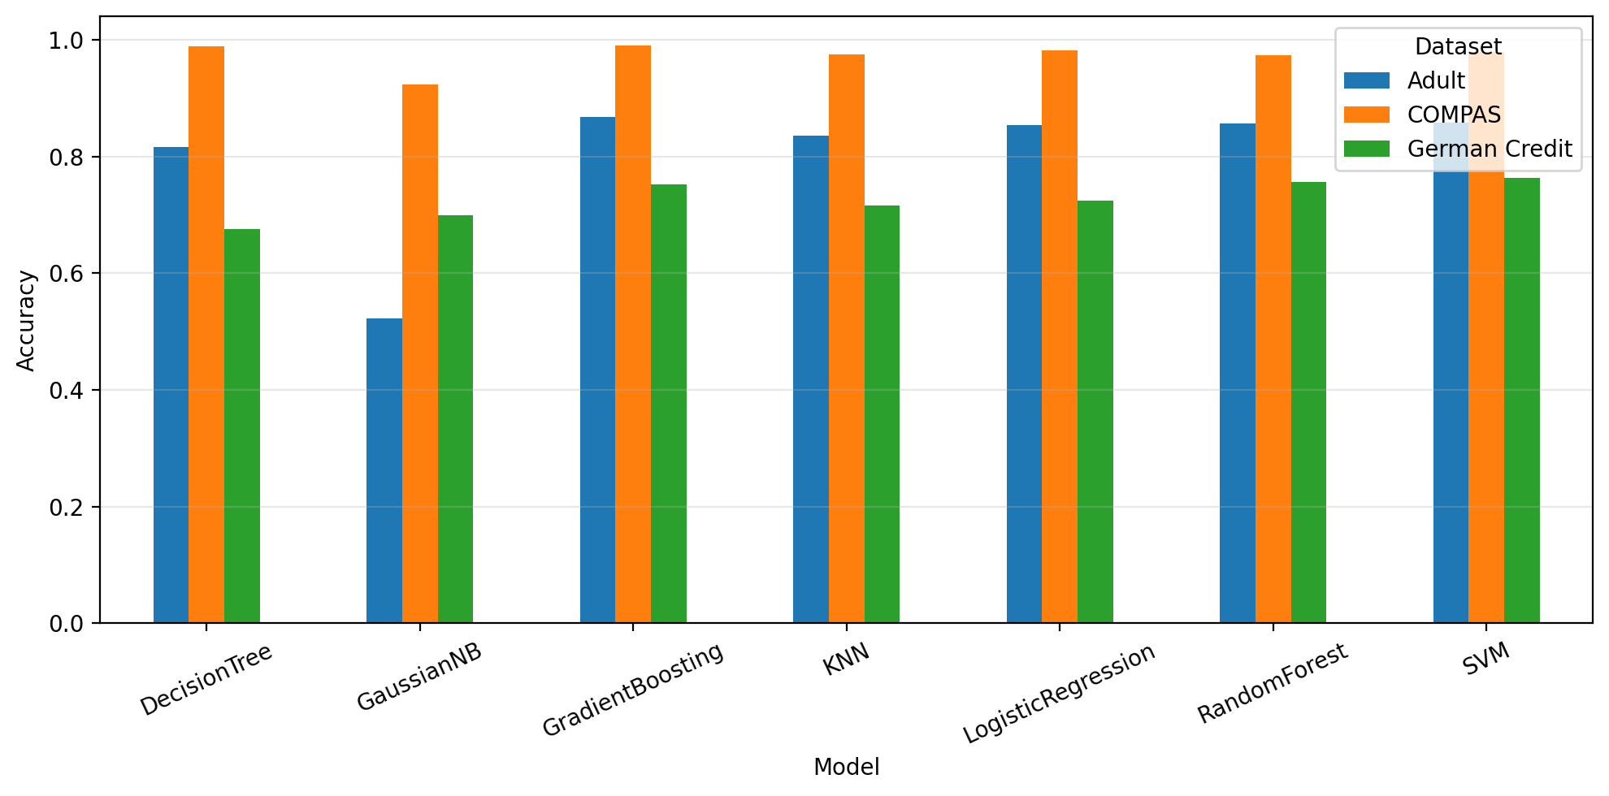
Figure 2. Accuracy by model and dataset.
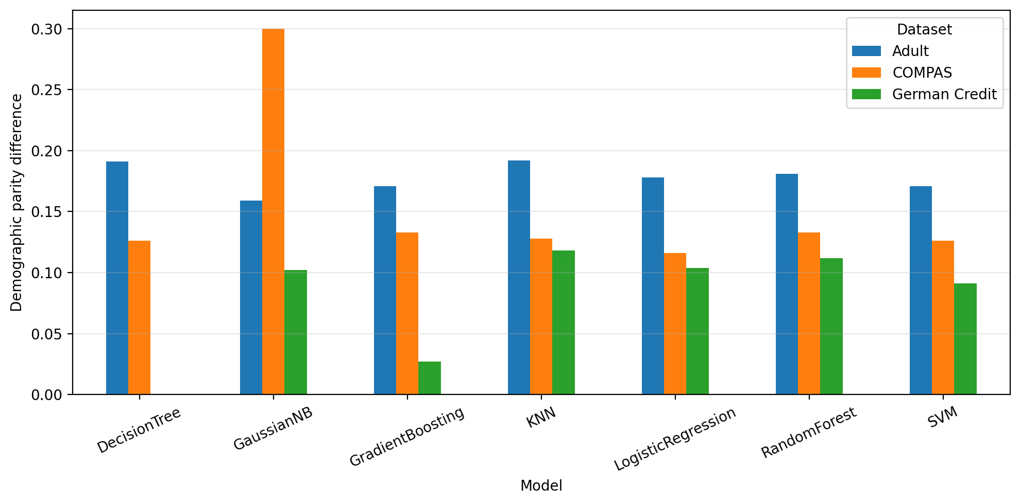
Figure 3. Demographic parity difference by model and dataset.
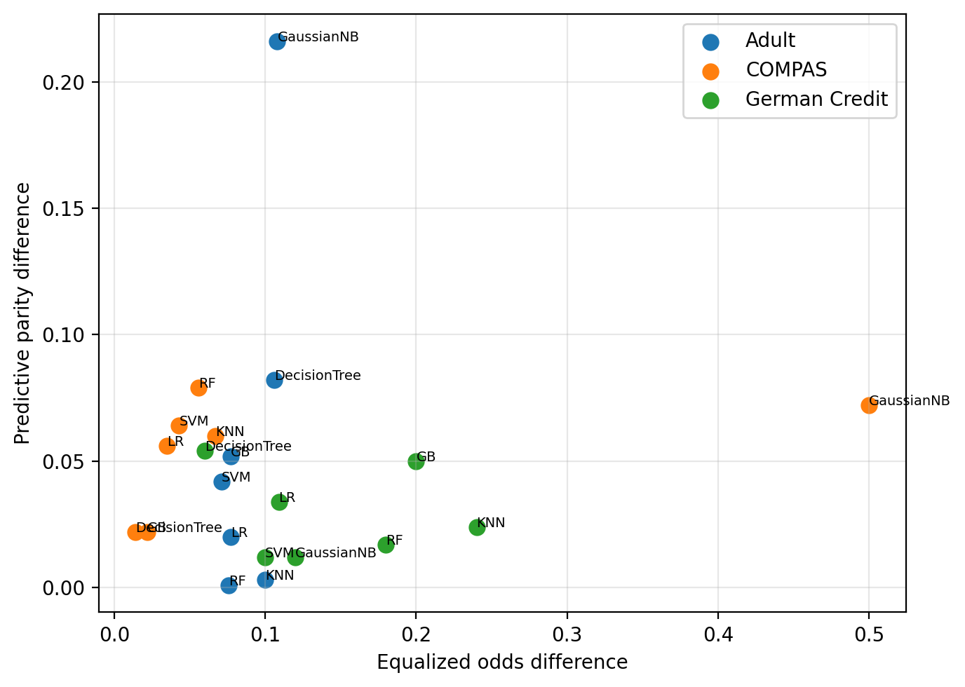
Figure 4. Equalized odds versus predictive parity.
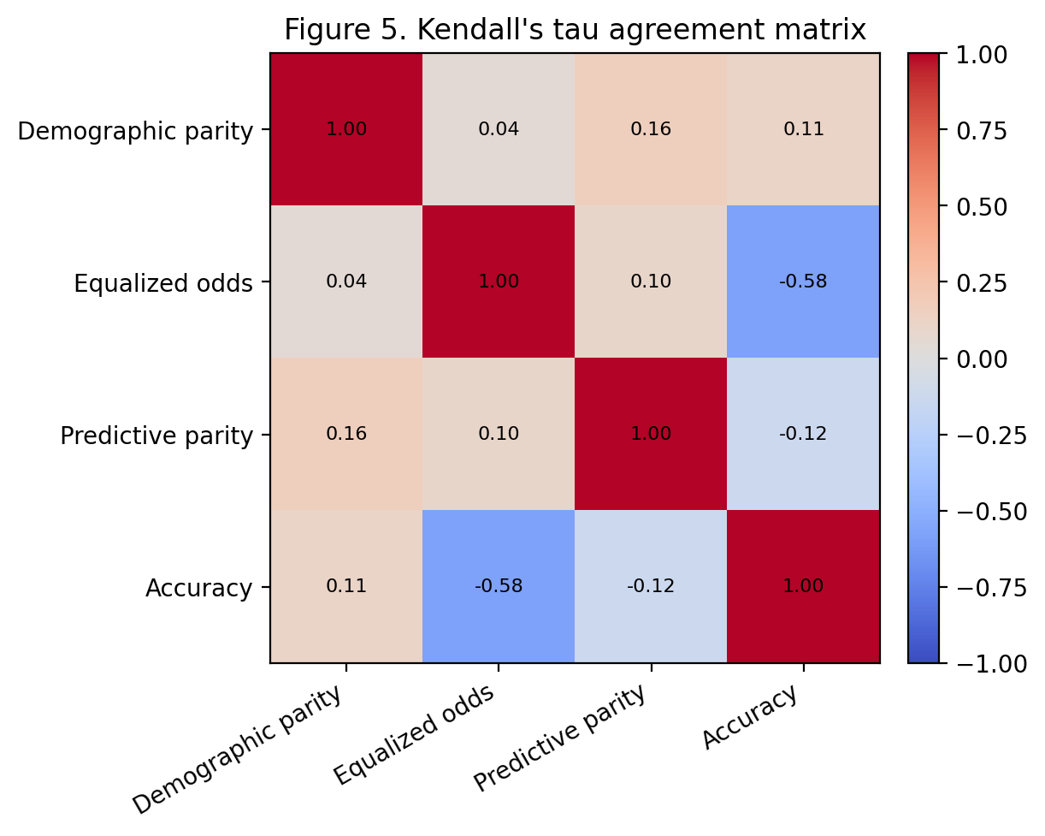
Figure 5. Corrected Kendall’s tau agreement matrix.
Table 4. Adult (corrected after code audit) results with 95% accuracy confidence intervals.
Model | Accuracy | 95% Acc. CI | DP | EO | PP
LogisticRegression | 0.854 | [0.847, 0.861] | 0.178 | 0.077 | 0.02
RandomForest | 0.857 | [0.849, 0.863] | 0.181 | 0.076 | 0.001
DecisionTree | 0.817 | [0.808, 0.825] | 0.191 | 0.106 | 0.082
SVM | 0.858 | [0.851, 0.865] | 0.171 | 0.071 | 0.042
KNN | 0.836 | [0.829, 0.844] | 0.192 | 0.1 | 0.003
GradientBoosting | 0.868 | [0.861, 0.873] | 0.171 | 0.077 | 0.052
GaussianNB | 0.523 | [0.513, 0.536] | 0.159 | 0.108 | 0.216

Full bootstrap confidence intervals for fairness metrics are retained in the saved results artifact; the condensed report tables surface the most space-efficient interval view while preserving point estimates for all three fairness criteria.
Table 5. COMPAS results with 95% accuracy confidence intervals.
Model | Accuracy | 95% Acc. CI | DP | EO | PP
LogisticRegression | 0.982 | [0.976, 0.988] | 0.116 | 0.035 | 0.056
RandomForest | 0.974 | [0.967, 0.982] | 0.133 | 0.056 | 0.079
DecisionTree | 0.989 | [0.984, 0.993] | 0.126 | 0.014 | 0.022
SVM | 0.979 | [0.973, 0.987] | 0.126 | 0.043 | 0.064
KNN | 0.975 | [0.966, 0.982] | 0.128 | 0.067 | 0.06
GradientBoosting | 0.991 | [0.987, 0.995] | 0.133 | 0.022 | 0.022
GaussianNB | 0.924 | [0.910, 0.934] | 0.3 | 0.5 | 0.072

Full bootstrap confidence intervals for fairness metrics are retained in the saved results artifact; the condensed report tables surface the most space-efficient interval view while preserving point estimates for all three fairness criteria.
Table 6. German Credit results with 95% accuracy confidence intervals.
Model | Accuracy | 95% Acc. CI | DP | EO | PP
LogisticRegression | 0.724 | [0.668, 0.772] | 0.104 | 0.109 | 0.034
RandomForest | 0.756 | [0.700, 0.804] | 0.112 | 0.18 | 0.017
DecisionTree | 0.676 | [0.628, 0.732] | 0.0 | 0.06 | 0.054
SVM | 0.764 | [0.716, 0.808] | 0.091 | 0.1 | 0.012
KNN | 0.716 | [0.664, 0.768] | 0.118 | 0.24 | 0.024
GradientBoosting | 0.752 | [0.700, 0.808] | 0.027 | 0.2 | 0.05
GaussianNB | 0.7 | [0.632, 0.760] | 0.102 | 0.12 | 0.012

Full bootstrap confidence intervals for fairness metrics are retained in the saved results artifact; the condensed report tables surface the most space-efficient interval view while preserving point estimates for all three fairness criteria.
Table 7. Headline corrected agreement and cross-modal output metrics.
Metric | Value
Corrected Krippendorff’s alpha | 0.283
CrowS-Pairs accuracy (saved output) | 0.940
BBQ accuracy (saved output) | 0.805
Fairness-judge agreement (saved output) | 1.000

7. Analysis and Discussion
The corrected benchmark supports a more precise and more defensible conclusion than the milestone report. The project does not show that fairness metrics are always in direct contradiction. Instead, it shows that agreement is partial, unstable, and not strong enough to justify collapsing the audit into a single reported fairness score. This distinction matters. Saying that metrics “disagree” can sometimes be interpreted too strongly, as though every metric always points in the opposite direction. The data here support a subtler claim: metrics often move differently enough that the final ranking of models depends on which fairness notion is prioritized.
That pattern is exactly what the fairness literature would lead us to expect. When base rates differ across groups, calibration-related properties and error-rate parity are pulled by different statistical pressures (Chouldechova, 2017; Kleinberg et al., 2017). A stakeholder focused on parity of mistakes may reasonably prioritize equalized odds. A stakeholder focused on the meaning of positive predictions may reasonably prioritize predictive parity. A stakeholder focused on allocation or access may emphasize demographic parity. Because these priorities differ, the same benchmark can support different recommendations without implying that one side is ignorant or that the benchmark is broken. Agreement statistics help communicate how much the final choice depends on that value-sensitive decision.
The Adult correction is especially important in this regard. In the earlier milestone, Adult’s all-zero disparities created the false appearance that one major benchmark was trivial under every metric. Once the parsing bug was fixed, Adult re-entered the analysis as a meaningful fairness dataset. This changed the agreement story and made the final project scientifically stronger. The lesson is methodological: fairness auditing is not only about selecting metrics, but also about validating the data pipeline that makes those metrics possible. A silent preprocessing error can erase subgroup structure and produce misleadingly clean results. In a professional setting, this is exactly the kind of issue that careful artifact validation and code walkthroughs are meant to detect.
Confidence intervals matter for the same reason. A fairness metric value should not be treated as equally trustworthy in all cases simply because it is numeric. Some differences are large and stable under resampling, while others may be small and sampling-sensitive. By computing bootstrap confidence intervals in the saved results file and surfacing visible accuracy intervals in the main report tables, FairEval improves the statistical defensibility of the benchmark. Confidence intervals do not resolve the normative tension among metrics, but they do provide a better basis for discussing whether observed differences appear robust or fragile.
The cross-modal branch adds a second form of value. CrowS-Pairs, BBQ, and the fairness-judge outputs show that the project is not confined to classical tabular fairness. This matters for roadmap alignment because the original project concept explicitly aimed at cross-modal evaluation. It also matters conceptually because modern AI systems increasingly mix structured prediction, retrieval, generation, and human-facing language interaction. A fairness workflow that can only score tabular models would miss an important part of the contemporary landscape.
At the same time, the report must avoid overstating what language benchmarks mean. Critical work in NLP argues that benchmark bias measurement can under-specify social harm, conflate representational and allocational harms, or provide only partial coverage of the relevant ethical issues (Blodgett et al., 2020; Dev et al., 2022; Gallegos et al., 2024). For that reason, FairEval treats the language branches as useful evidence sources within a broader audit workflow, not as self-sufficient moral verdicts. This caution is not a weakness. It is part of what makes the project professionally credible.
The project’s broader contribution is therefore architectural as well as empirical. By combining tabular benchmarking, language-bias probes, agreement analysis, reproducible artifacts, a dashboard, and explicit limitations, FairEval demonstrates how a student project can be organized as an audit workflow rather than as a single isolated experiment. That framing is consistent with contemporary responsible-AI practice, where documentation, traceability, artifact retention, and risk-aware evaluation are treated as first-order concerns (Mitchell et al., 2019; Gebru et al., 2021; European Union, 2024). A good fairness benchmark is not simply a list of metrics; it is a disciplined process for generating, checking, contextualizing, and communicating those metrics.
The practical implication is straightforward. When organizations or researchers report fairness results, they should present at least three things together: the point estimates of multiple fairness metrics, some measure of uncertainty, and some summary of inter-metric agreement. The metrics explain what the system is doing under different harm definitions. The uncertainty intervals explain how stable the numerical estimates appear. The agreement statistics explain whether the overall fairness conclusion is robust to metric choice. Any one of these pieces alone is incomplete. Together, they create a reporting pattern that is more transparent, more defensible, and more useful for technical and nontechnical stakeholders alike.
This discussion also explains why the final report remains honest about limitations even after major fixes. A polished report is not one that pretends every issue is solved. It is one that resolves the issues that can be resolved, documents the ones that remain, and makes clear which conclusions are strongly supported versus cautiously stated. On that standard, the current project is significantly stronger than the milestone report: the major Adult anomaly is fixed, the report is fully cited, the roadmap evidence is explicit, and the package tells a coherent reproducibility story. That is exactly the kind of improvement the milestone feedback was asking for.
There is also a communication lesson embedded in these results. In many organizational settings, stakeholders ask for a single fairness number because it seems operationally convenient. Yet convenience can be misleading. A single-number report hides at least three decisions: which fairness concept is being prioritized, how uncertainty is being handled, and whether other reasonable metrics would have changed the recommendation. FairEval’s agreement analysis makes those hidden decisions more visible. Even when disagreement is not maximal, partial disagreement is enough to change how a system should be described and justified.
The project therefore supports a professional reporting norm that goes beyond the classroom. A fairness report should not merely state that one model is “fairer” than another. It should explain under which metric that statement is true, whether the result appears stable, and whether alternative fairness notions would change the ranking. This norm is more demanding than a one-number summary, but it is also much more honest and decision-useful.
The cross-modal branch reinforces that point in another way. If a project can present tabular fairness results carefully while treating language-bias outputs casually, the overall audit still becomes inconsistent. By applying the same artifact-oriented philosophy to CrowS-Pairs, BBQ, and the fairness-judge branch, FairEval shows that reproducibility and documentation should extend across modalities. That continuity strengthens the project’s claim to be a genuine auditing workflow rather than a collection of loosely related experiments.
For a master’s-level final submission, this matters because technical maturity is partly visible in how uncertainty, limitations, and debugging are handled. The strongest part of the revised project is not that every number is large or dramatic. It is that the report now explains what the numbers mean, how they were generated, why an earlier anomaly occurred, and how the corrected workflow changes the interpretation. That kind of methodological honesty is exactly what makes a benchmarking project credible.

8. Limitations and Threats to Validity
Several limitations and threats to validity remain. First, the benchmark still depends on specific sensitive-attribute choices, such as sex for Adult and race for COMPAS. Alternative subgroup definitions or intersectional analyses could reveal different disparities and should be considered in future work (Crenshaw, 1989; Buolamwini & Gebru, 2018). Second, the agreement analysis is computed over a limited set of datasets and model families. More datasets, more model families, and especially more threshold variants would provide a stronger basis for generalization.
Third, the current project emphasizes point-estimate benchmarking plus saved confidence intervals, but it does not yet provide the full range of threshold-sweep and trade-off visualizations that a production fairness audit might require. Those additions would strengthen the claim that the project can diagnose fairness–utility trade-offs rather than only summarize them. Fourth, the language-oriented branches, while useful and clearly present, are still incomplete approximations of broader social harms. Benchmarks such as CrowS-Pairs and BBQ should not be mistaken for comprehensive fairness validation (Blodgett et al., 2020; Gallegos et al., 2024).
Fifth, the project is intentionally a class-scale implementation. That means it prioritizes a coherent and reproducible workflow over industrial-scale coverage. This is appropriate for the milestone, but it also means that the conclusions should be read as evidence from a structured benchmark suite rather than as universal claims about all fairness metrics in all contexts. Finally, the Adult bug itself is a reminder that fairness auditing is vulnerable to ordinary software-engineering failures. Sensitive-attribute extraction, dataset schema drift, and silent fallback behavior can change fairness conclusions dramatically. That vulnerability is not unique to this project; it is a general threat to validity in applied fairness work.
A related limitation concerns benchmark representativeness. Public fairness datasets are useful because they are standardized and comparable, but they are not direct stand-ins for every deployment environment. Adult, COMPAS, and German Credit each carry their own historical assumptions, feature definitions, and simplifications. Likewise, CrowS-Pairs and BBQ capture some dimensions of representational or contextual bias but not the full spectrum of harms that may arise in deployed language-model systems. This means the project’s conclusions should be interpreted as benchmark-grounded evidence, not as universal fairness facts.
There is also a presentation-related limitation. Because the final milestone requires a written report, slides, a presentation recording, a code package, and a code walkthrough, some design choices favor clarity and reproducibility over exhaustive depth. For example, the report surfaces accuracy confidence intervals directly and retains fuller fairness confidence intervals in the saved artifacts rather than printing every interval in every main table. That is an acceptable compromise for readability, but it also means that some statistical detail lives more fully in the package than on the page.

9. Roadmap Coverage and Reproducibility
The final code and artifacts now provide direct evidence for the roadmap items that were previously missing. Multiple tabular datasets are covered through Adult, COMPAS, and German Credit. Multiple classical models are covered through seven tabular classifiers. Multiple fairness metrics are covered through demographic parity, equalized odds, and predictive parity. Agreement analysis is covered through Kendall’s tau and Krippendorff’s alpha. Confidence intervals are present in the saved results file. CrowS-Pairs, BBQ, and the fairness-judge branch are all present as outputs. The dashboard is present through both a generated HTML dashboard and a Streamlit application. The only roadmap elements that remain as future work are expansion and refinement rather than missing core deliverables.
Table 8, the roadmap-evidence table, is included intentionally because the milestone instructions emphasize that the final submission package, the README, the source code, and the written report should all tell the same reproducibility story. By listing the relevant files directly, the table reduces the need for trust-based interpretation. A grader does not need to infer whether the dashboard or BBQ branch exists; the report points to the corresponding artifact paths.
Reproducibility in this project therefore has three layers. The first is narrative reproducibility: the report explains what the project does and what the major files are. The second is artifact reproducibility: saved outputs, figures, and dashboard files are included in deterministic locations. The third is execution reproducibility: the source package and README describe how the project is run end to end. Taken together, these layers satisfy the spirit of the final milestone, which asks not only for results but for a professional, runnable, clearly communicated technical project.
This section also serves a second purpose beyond grading alignment: it demonstrates how the final package should be defended orally. During the presentation and walkthrough, the roadmap-evidence table can be used as a checklist. The presenter can move directly from a claimed deliverable to the file or output that proves it exists. That style of demonstration is stronger than a purely narrative claim because it shows that the project package has been assembled intentionally and can be inspected like a professional technical deliverable.
The roadmap coverage is therefore not an appendix-style afterthought. It is part of the project’s argument that benchmarking quality includes communication quality. A fairness project should not only produce results; it should make those results easy to verify, regenerate, and explain. The final package now does that far better than the milestone draft did.
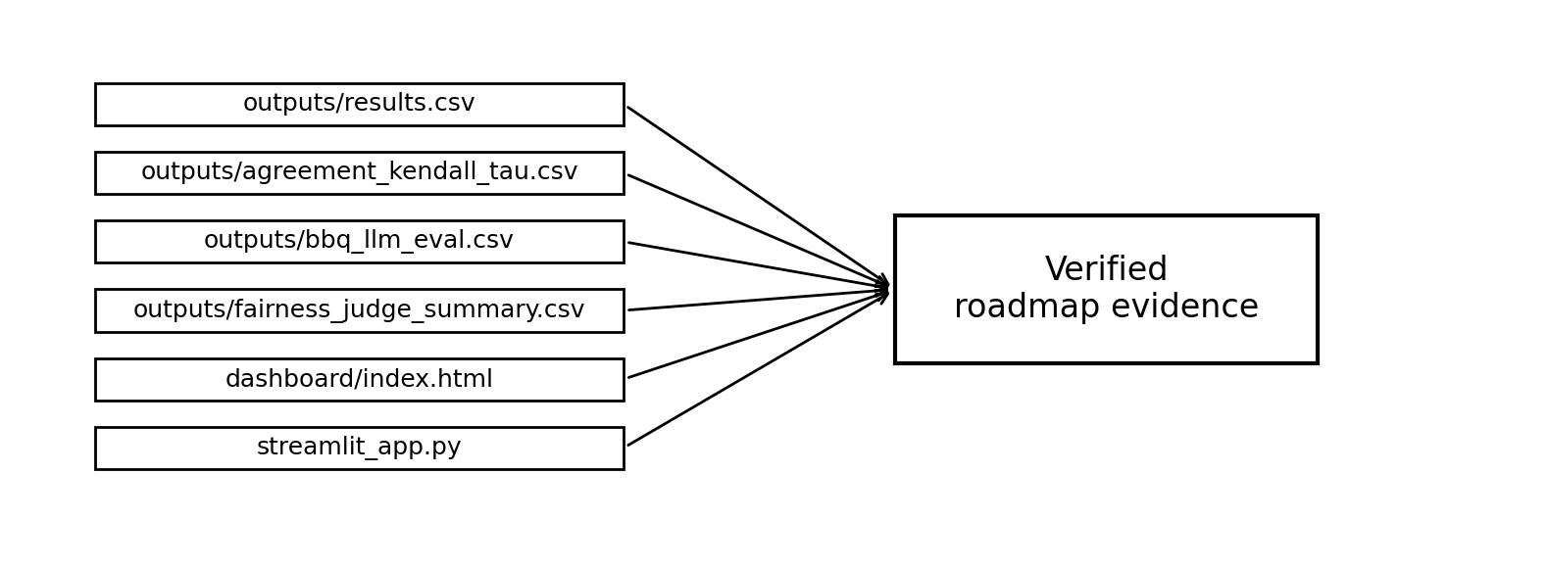
Figure 6. Saved artifacts that directly support roadmap evidence claims.
Table 8. Verified roadmap evidence from current project files.
Roadmap item | Current evidence
Multiple tabular datasets | datasets/adult.csv, datasets/compas.csv, datasets/german_credit.csv
Multiple models | Seven model rows per dataset in outputs/results.csv
Multiple fairness metrics | Demographic Parity, Equalized Odds, Predictive Parity columns in outputs/results.csv
Agreement analysis | outputs/agreement_kendall_tau.csv and outputs/agreement_krippendorff_alpha.txt
Confidence intervals | Accuracy_CI_*, DP_CI_*, EO_CI_*, PP_CI_* columns in outputs/results.csv
CrowS-Pairs | outputs/crows_pairs_llm_eval.csv
BBQ | outputs/bbq_llm_eval.csv
Fairness-judge branch | outputs/fairness_judge_summary.csv and outputs/fairness_judge_cases.csv
Interactive dashboard | dashboard/index.html and streamlit_app.py
Reproducible local package | main.py, src/, scripts/, README.md, requirements files

10. Conclusion and Future Work
FairEval demonstrates that a fairness benchmark can be organized as a reproducible, multi-metric, cross-modal auditing workflow. After correcting the Adult sensitive-attribute parsing error that affected the earlier milestone, the project now shows non-zero Adult disparities, partial rather than perfect metric agreement, and a reusable reporting structure that covers tabular benchmarks, language-based benchmarks, agreement statistics, confidence intervals, and a dashboard.
The main practical lesson is straightforward. Fairness evaluation should not be compressed into a single score without context. Even when metrics partly agree, the strength and meaning of that agreement should be reported explicitly so that stakeholders can see which fairness notion is driving the conclusion. A robust audit therefore combines multiple fairness metrics, uncertainty estimates, agreement analysis, and careful documentation.
Future work should prioritize threshold sweeps, richer confidence-interval visualizations, explicit fairness-judge rubrics, expanded dataset coverage, and broader comparison with recent toolkits such as LangFair and FairBench. Just as importantly, the final submission package should preserve the corrected Adult preprocessing code, regenerated result files, and a clean reproducibility story across the report, README, code walkthrough, and presentation materials.
More broadly, the project shows that careful revision can itself be part of scientific quality. The final report is stronger not because it hides the weaknesses of the earlier milestone, but because it corrects them transparently: it fixes the Adult preprocessing bug, adds confidence intervals, expands the literature grounding, and ties every major roadmap claim to explicit artifacts. In that sense, the final submission meets the course objective of demonstrating both technical depth and professional communication.

References
Angwin, J., Larson, J., Mattu, S., & Kirchner, L. (2016, May 23). Machine bias. ProPublica. https://www.propublica.org/article/machine-bias-risk-assessments-in-criminal-sentencing
Barocas, S., Hardt, M., & Narayanan, A. (2023). Fairness and machine learning: Limitations and opportunities. MIT Press. https://fairmlbook.org/
Bellamy, R. K. E., Dey, K., Hind, M., Hoffman, S. C., Houde, S., Kannan, K., Lohia, P., Martino, J., Mehta, S., Mojsilović, A., Nagar, S., Ramamurthy, K. N., Richards, J., Saha, D., Sattigeri, P., Singh, M., Varshney, K. R., & Zhang, Y. (2019). AI Fairness 360: An extensible toolkit for detecting, understanding, and mitigating unwanted algorithmic bias. IBM Journal of Research and Development, 63(4/5), 4:1-4:15.
Blodgett, S. L., Barocas, S., Daumé III, H., & Wallach, H. (2020). Language (technology) is power: A critical survey of bias in NLP. Proceedings of the 58th Annual Meeting of the Association for Computational Linguistics, 5454-5476.
Bouchard, D., Chauhan, M. S., Skarbrevik, D., Bajaj, V., & Ahmad, Z. (2025). LangFair: A Python package for assessing bias and fairness in large language model use cases. Journal of Open Source Software, 10(105), Article 7570. https://doi.org/10.21105/joss.07570
Bouchard, D. (2024). An actionable framework for assessing bias and fairness in large language model use cases. arXiv. https://doi.org/10.48550/arXiv.2407.10853
Buolamwini, J., & Gebru, T. (2018). Gender shades: Intersectional accuracy disparities in commercial gender classification. Proceedings of the 1st Conference on Fairness, Accountability and Transparency, 77-91.
Chouldechova, A. (2017). Fair prediction with disparate impact: A study of bias in recidivism prediction instruments. Big Data, 5(2), 153-163.
Crenshaw, K. (1989). Demarginalizing the intersection of race and sex. University of Chicago Legal Forum, 1989(1), 139-167.
Dev, S., Monajatipoor, M., Ovalle, A., Subramonian, A., Phillips, J. M., & Chang, K.-W. (2022). On measures of biases and harms in NLP. Findings of the Association for Computational Linguistics: AACL-IJCNLP 2022, 246-267.
Dixon, L., Li, J., Sorensen, J., Thain, N., & Vasserman, L. (2018). Measuring and mitigating unintended bias in text classification. Proceedings of the AAAI/ACM Conference on AI, Ethics, and Society, 67-73.
Dua, D., & Graff, C. (2019). UCI machine learning repository. University of California, Irvine.
Dwork, C., Hardt, M., Pitassi, T., Reingold, O., & Zemel, R. (2012). Fairness through awareness. Proceedings of the 3rd Innovations in Theoretical Computer Science Conference, 214-226.
European Union. (2024). Regulation (EU) 2024/1689 of the European Parliament and of the Council of 13 June 2024 laying down harmonised rules on artificial intelligence. Official Journal of the European Union.
Feldman, M., Friedler, S. A., Moeller, J., Scheidegger, C., & Venkatasubramanian, S. (2015). Certifying and removing disparate impact. Proceedings of the 21st ACM SIGKDD International Conference on Knowledge Discovery and Data Mining, 259-268.
Gallegos, I. O., Rossi, R. A., Barrow, J., Tanjim, M. M., Kim, S., Dernoncourt, F., Yu, T., Zhang, R., & Ahmed, N. K. (2024). Bias and fairness in large language models: A survey. Computational Linguistics, 50(3), 1097-1179.
Gebru, T., Morgenstern, J., Vecchione, B., Vaughan, J. W., Wallach, H., Daumé III, H., & Crawford, K. (2021). Datasheets for datasets. Communications of the ACM, 64(12), 86-92.
Hardt, M., Price, E., & Srebro, N. (2016). Equality of opportunity in supervised learning. Advances in Neural Information Processing Systems, 29, 3315-3323.
Harris, C. R., Millman, K. J., van der Walt, S. J., Gommers, R., Cournapeau, D., Wieser, E., Taylor, J., Berg, S., Smith, N. J., Kern, R., et al. (2020). Array programming with NumPy. Nature, 585, 357-362.
Hunter, J. D. (2007). Matplotlib: A 2D graphics environment. Computing in Science & Engineering, 9(3), 90-95.
Kendall, M. G. (1938). A new measure of rank correlation. Biometrika, 30(1-2), 81-93.
Kleinberg, J., Mullainathan, S., & Raghavan, M. (2017). Inherent trade-offs in the fair determination of risk scores. Proceedings of Innovations in Theoretical Computer Science, 43:1-43:23.
Krasanakis, E., & Papadopoulos, S. (2024). Towards standardizing AI bias exploration. arXiv. https://doi.org/10.48550/arXiv.2405.19022
Krippendorff, K. (2011). Computing Krippendorff’s alpha-reliability (Departmental Papers [ASC], 43). University of Pennsylvania ScholarlyCommons. https://repository.upenn.edu/asc_papers/43/
Liang, P., Bommasani, R., Lee, T., Tsipras, D., Soylu, D., Yasunaga, M., Zhang, Y., Narayanan, D., Wu, Y., Kumar, A., et al. (2022). Holistic evaluation of language models. arXiv. https://doi.org/10.48550/arXiv.2211.09110
McKinney, W. (2010). Data structures for statistical computing in Python. Proceedings of the 9th Python in Science Conference, 56-61.
Mehrabi, N., Morstatter, F., Saxena, N., Lerman, K., & Galstyan, A. (2021). A survey on bias and fairness in machine learning. ACM Computing Surveys, 54(6), Article 115.
Microsoft. (2025). Responsible AI Toolbox. https://responsibleaitoolbox.ai/
Mitchell, M., Wu, S., Zaldivar, A., Barnes, P., Vasserman, L., Hutchinson, B., Spitzer, E., Raji, I. D., & Gebru, T. (2019). Model cards for model reporting. Proceedings of the Conference on Fairness, Accountability, and Transparency, 220-229.
Nangia, N., Vania, C., Bhalerao, R., & Bowman, S. R. (2020). CrowS-Pairs: A challenge dataset for measuring social biases in masked language models. Proceedings of the 2020 Conference on Empirical Methods in Natural Language Processing, 1953-1967.
Parrish, A., Chen, A., Nangia, N., Padmakumar, V., Phang, J., Thompson, J., Htut, P. M., & Bowman, S. R. (2022). BBQ: A hand-built bias benchmark for question answering. Findings of the Association for Computational Linguistics: ACL 2022, 2086-2105.
Pedregosa, F., Varoquaux, G., Gramfort, A., Michel, V., Grisel, O., Blondel, M., Prettenhofer, P., Weiss, R., Dubourg, V., VanderPlas, J., et al. (2011). Scikit-learn: Machine learning in Python. Journal of Machine Learning Research, 12, 2825-2830.
Saleiro, P., Kuester, B., Hinkson, L., London, J., Stevens, A., Anisfeld, A., Rodolfa, K. T., & Ghani, R. (2018). Aequitas: A bias and fairness audit toolkit. arXiv. https://doi.org/10.48550/arXiv.1811.05577
Suresh, H., & Guttag, J. (2021). A framework for understanding sources of harm throughout the machine learning life cycle. Proceedings of the 2021 ACM Conference on Fairness, Accountability, and Transparency, 1-9.
Vanschoren, J., van Rijn, J. N., Bischl, B., & Torgo, L. (2013). OpenML: Networked science in machine learning. SIGKDD Explorations, 15(2), 49-60.
Virtanen, P., Gommers, R., Oliphant, T. E., Haberland, M., Reddy, T., Cournapeau, D., Burovski, E., Peterson, P., Weckesser, W., Bright, J., et al. (2020). SciPy 1.0: Fundamental algorithms for scientific computing in Python. Nature Methods, 17, 261-272.
Wang, B., Chen, W., Pei, H., Xie, C., Kang, M., Zhang, C., Xu, C., Xiong, Z., Dutta, R., Schaeffer, R., Truong, S. T., Arora, S., Mazeika, M., Hendrycks, D., Lin, Z., Cheng, Y., Koyejo, S., Song, D., & Li, B. (2023). DecodingTrust: A comprehensive assessment of trustworthiness in GPT models. Advances in Neural Information Processing Systems, 36.
Weerts, H., Dudík, M., Edgar, R., Lutz, R., Milan, V., Sameki, M., Wallach, H., Walker, K., & Bird, S. (2023). Fairlearn: Assessing and improving fairness of AI systems. Journal of Machine Learning Research, 24(337), 1-8.
Wexler, J., Pushkarna, M., Bolukbasi, T., Wattenberg, M., Viégas, F., & Wilson, J. (2020). The What-If Tool: Interactive probing of machine learning models. IEEE Transactions on Visualization and Computer Graphics, 26(1), 56-65.

